**Name : GAYATHRI A**

**Reg.No : 73152113029**

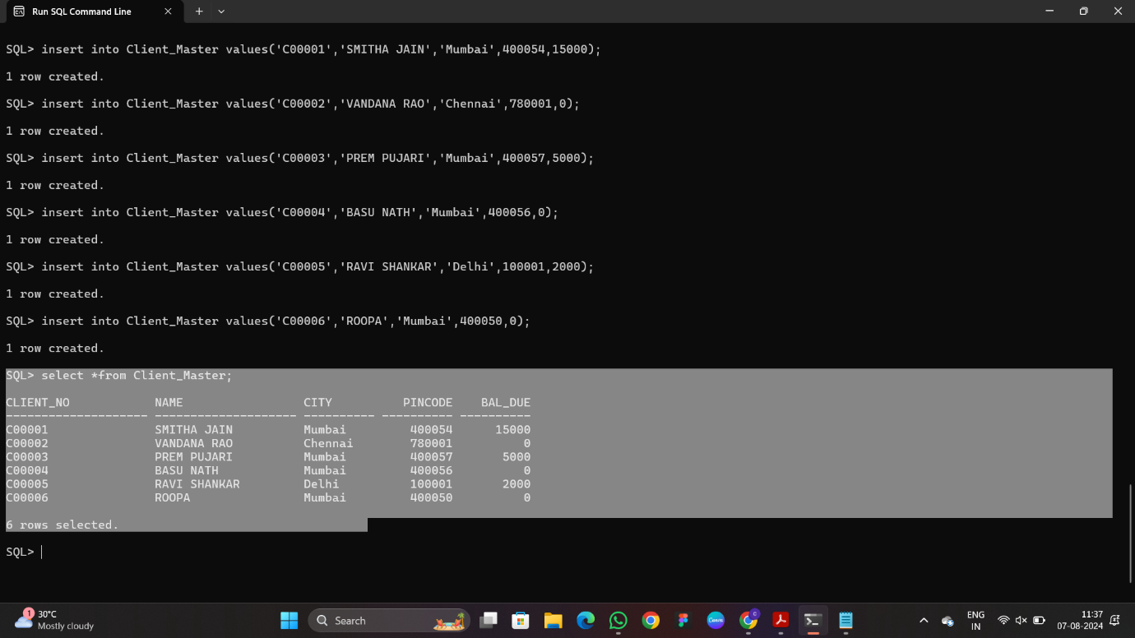

**1. List all details from the client_master table for clients whose Bal_due = 0.**

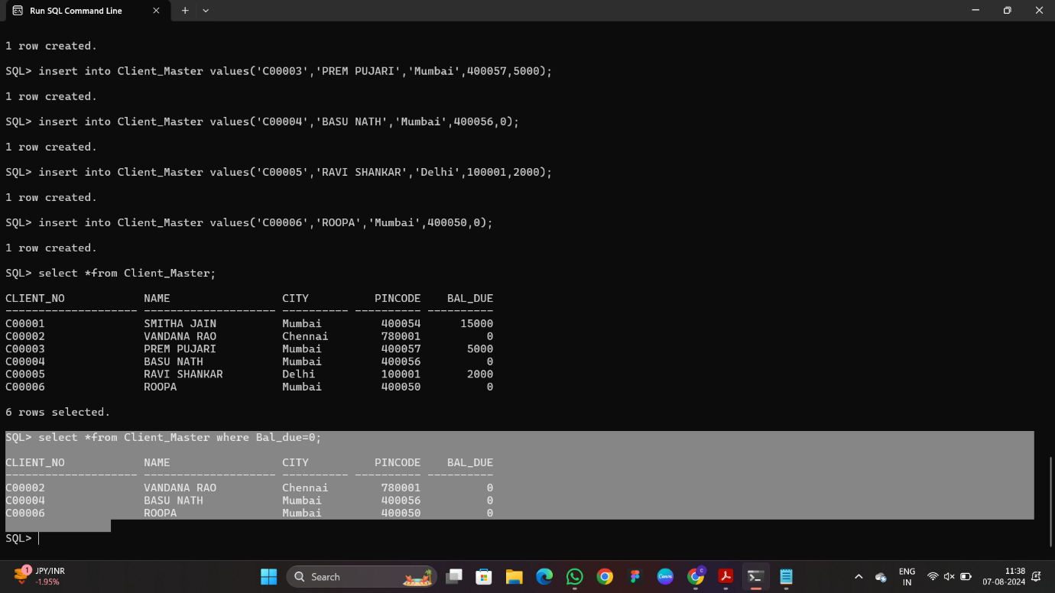

**2. Update table client_master, Change city of Client_no C00004 to Jaipur.**

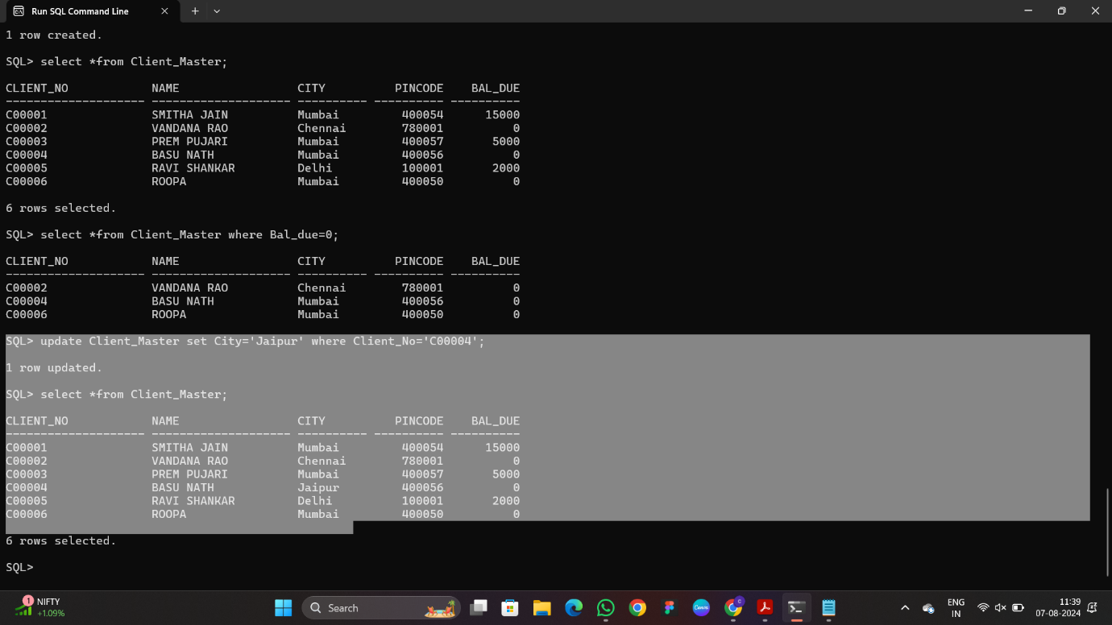

**3. Retrieve records of clients residing in Mumbai.**

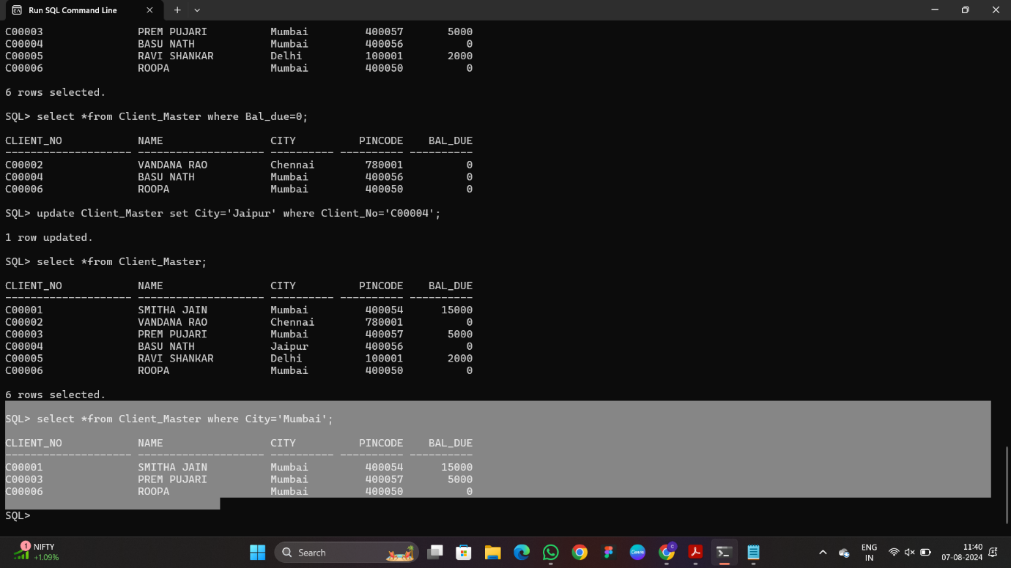

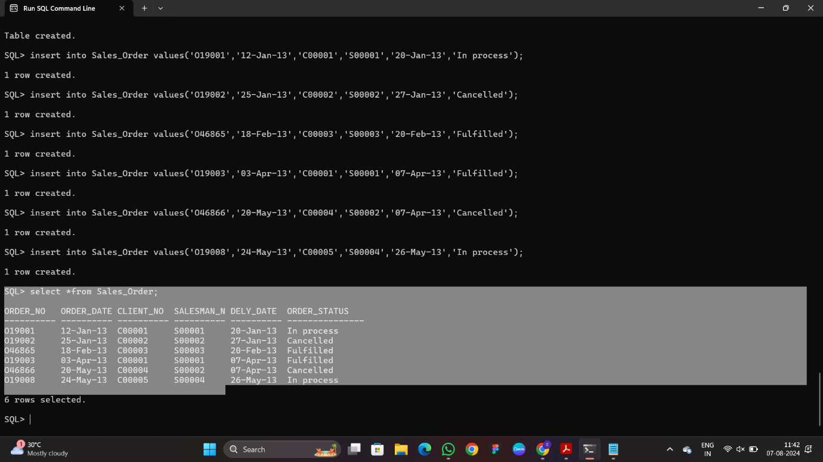

**4. Find the name and address of customer who has placed Order_no 'O19003' and 'O19002'**

**respectively.**

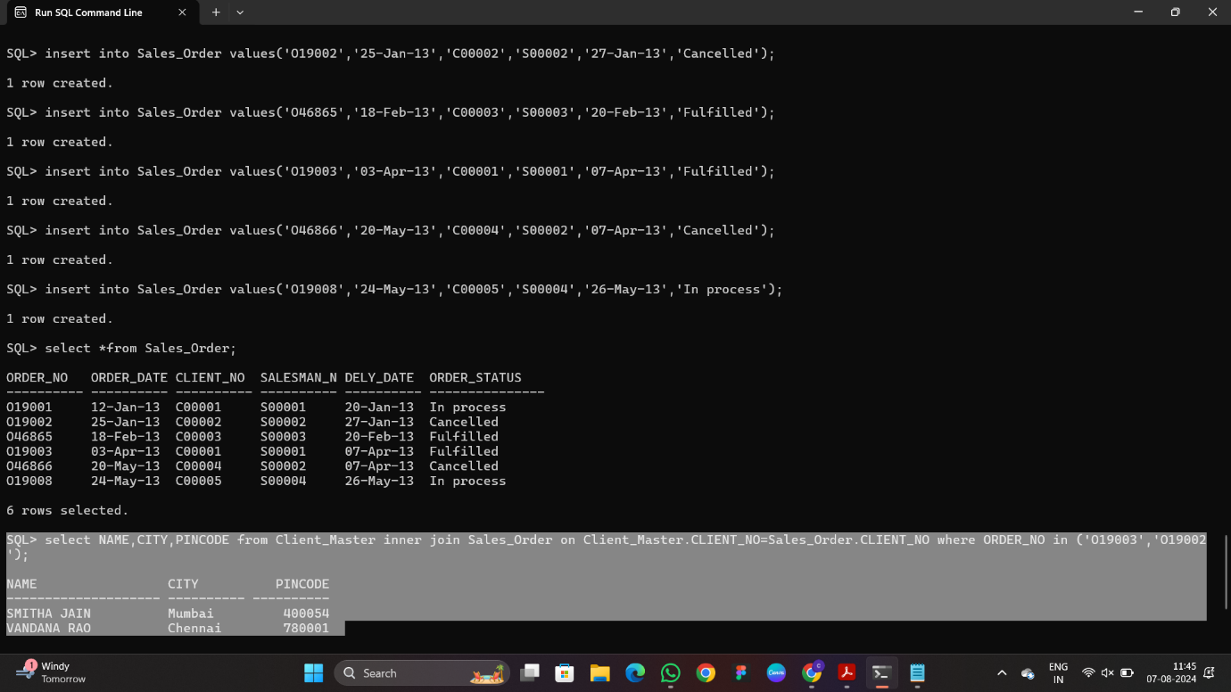

**5. Construct English like sentence from the table client_master ({Customer name} live in the city of**

**{city}).**

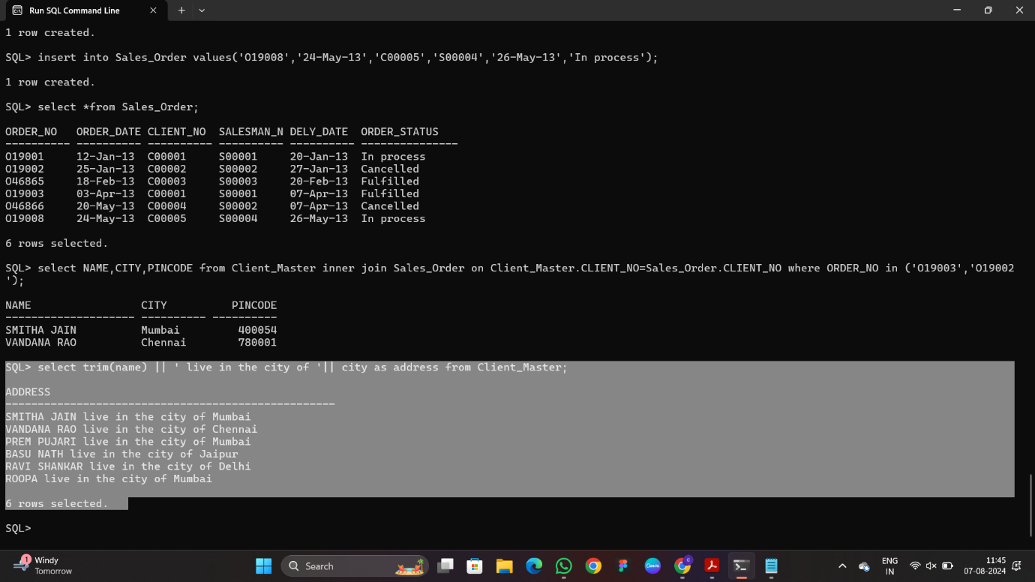

**6. List the client_no, name, city and pincode of clients whose Order_status is "In process".**

